Abstract Template of Third Workshop on Matter and Radiation WMR25

Abstract Title

A.A. First¹*, B.B. Second², C.C. Third^{1,2}
¹Affiliation, City, Country
²Affiliation, City, Country
*e-mail address of corresponding author

The abstracts should be submitted via e-mail (wmr@univ-batna.dz). Abstracts should be prepared as a Microsoft Word file (*.doc).The full volume of abstract (including text, drawings, figures, tables, and references). In order to ensure high quality of the volume of abstracts, the authors of accepted abstracts are kindly asked to submit an extended abstracts only in English. The aim of these extended abstracts is, firstly to advertise the topic considered in the paper and secondly to provide the readers with some detailed information. Please, describe briefly the area of interest, the basic assumptions and methods used, and highlight the main results of the paper. A list of basic references is highly recommended. This extended abstract should not exceed two A4 pages (21 × 29.7cm). The text should be typed in Times New Roman 14 pt font with 1.15 intervals. Text alignment - justify. Margins: left - 3 cm, right - 1.5 cm, top and bottom - 2 cm.
The text should include the following items in the order indicated:
1) Title of the report (Times New Roman 14 pt, bold, centered).
2) Authors (Times New Roman 14 pt: Authors should be separated by commas, initials should be preceded by the surname; the name of the speaker should be underlined).
3) Affiliation (affiliation, city, country) is italicized Times New Roman 12 pt, centered. If there are several affiliations, each of them begins with a new line and is numbered by the superscript (direct font), the names of authors also should be indexed by respective superscripts. The new line specifies the e-mail address for correspondence.
4) The main text (Times New Roman 14 pt).
Indent - 1 cm. The text should not be divided into any sections. References should be given in square brackets [1, 2-4]. Tables must have a clear structure; the column names should be simple and include all units of measure. The figures should be large enough in order to all the details are clearly visible (Fig. 1).
5) List of references (by a simple numbered list at the end of the abstract).
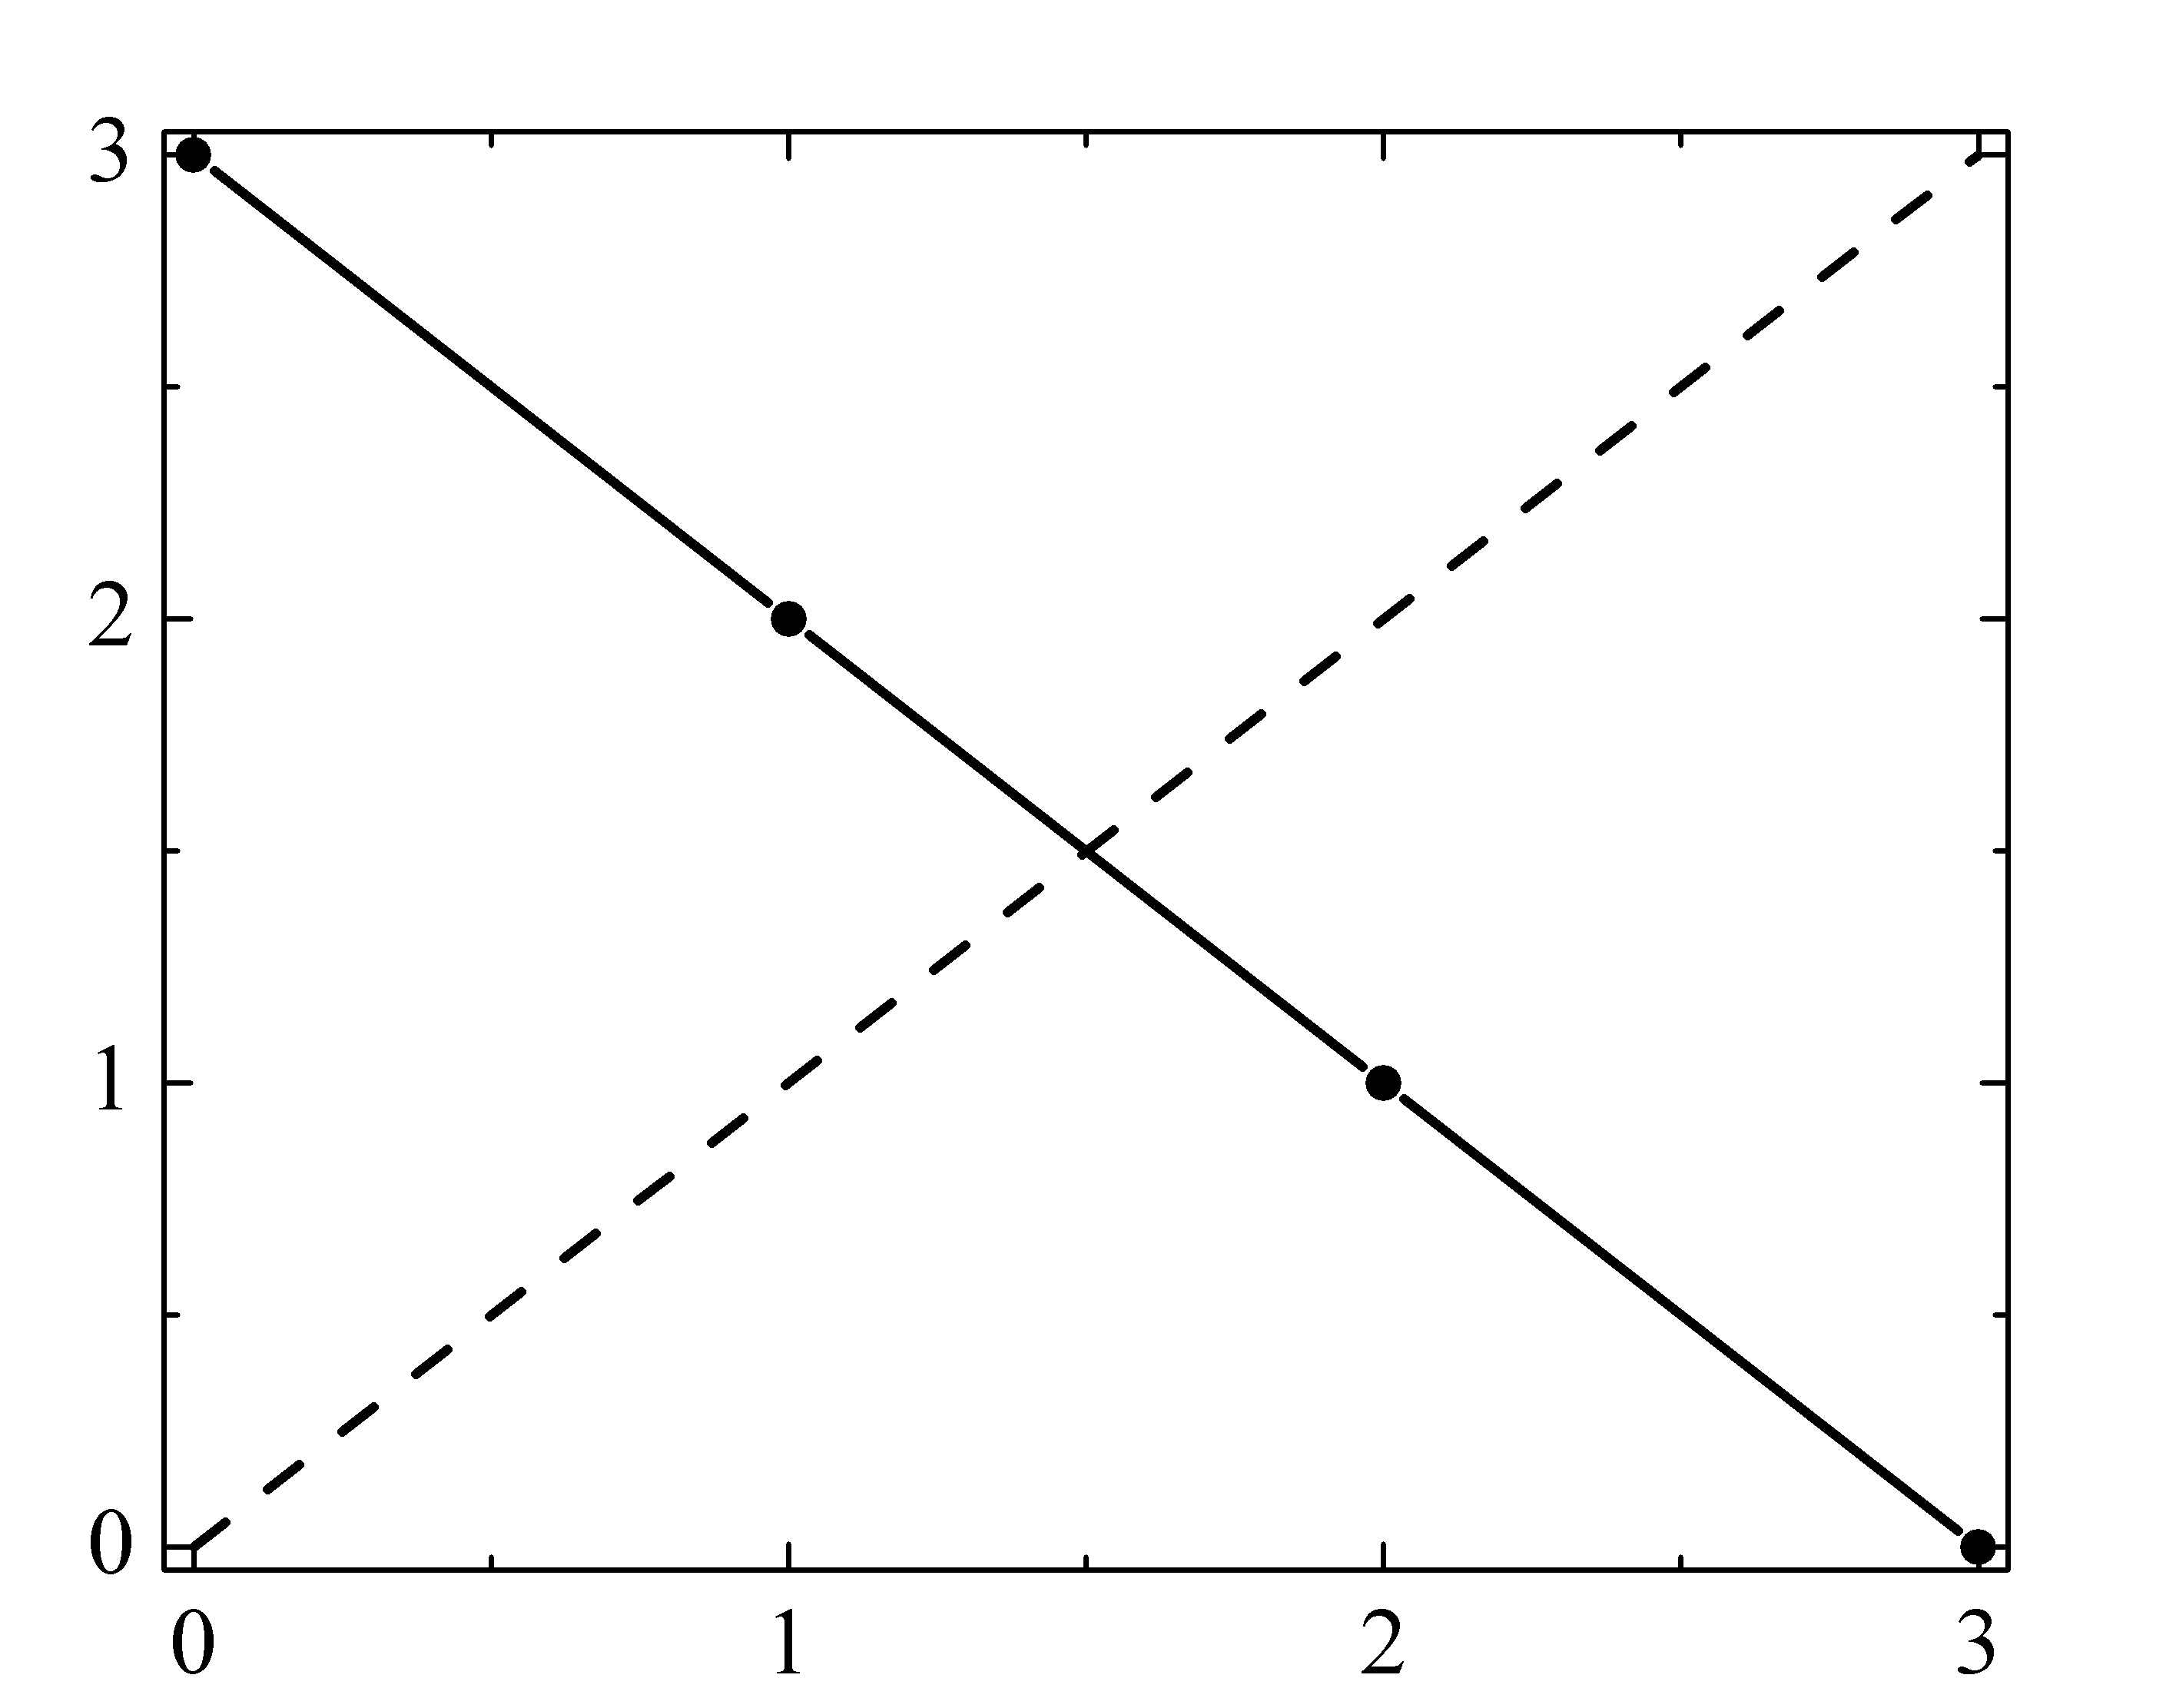
Fig. 1. Caption. (Times New Roman 12 pt)

[1] C.D. Eee, F.G. Hhh, J. Appl. Phys., 33 (1999) 133-136.

